import pandas as pd

import matplotlib.pyplot as plt

data = pd.read_csv("Social_Network_Ads.csv")

data.head()

output:

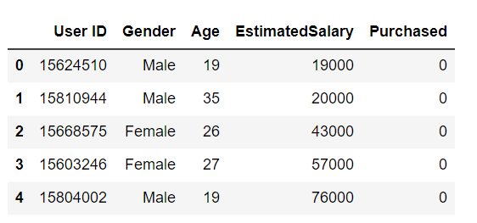

data = data[['Gender','Age','EstimatedSalary','Purchased']]

print(data.head())

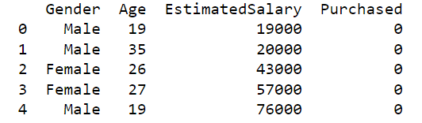

pd.get_dummies(data['Gender'])

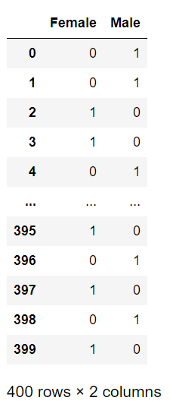

sex = pd.get_dummies(data['Gender'],drop_first=True)

sex.head()

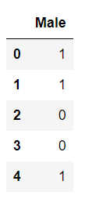

data_p = pd.concat([data,sex],axis=1)

data_p.head()

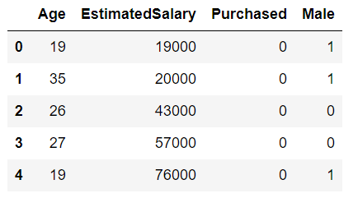

X = data_p[['Age','EstimatedSalary','Male']].values

y = data_p['Purchased'].values

from sklearn.model_selection import train_test_split

X_train,X_test,y_train,y_test = train_test_split(X,y,random_state=0,test_size=0.3)

from sklearn.preprocessing import StandardScaler

s = StandardScaler()

X_train = s.fit_transform(X_train)

X_test = s.fit_transform(X_test)

from sklearn.linear_model import LogisticRegression

log = LogisticRegression()

log.fit(X_train,y_train)

predict = log.predict(X_test)

from sklearn.metrics import classification_report,confusion_matrix

print(confusion_matrix(y_test,predict))

out: [[74 5]

[ 8 33]]

print(classification_report(y_test,predict))

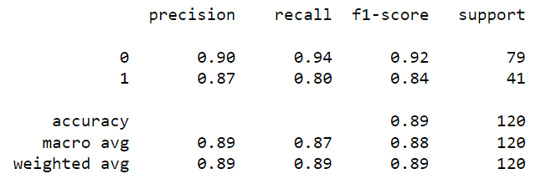

import seaborn as sns

sns.set(style="ticks")

sns.pairplot(data, hue="Gender")

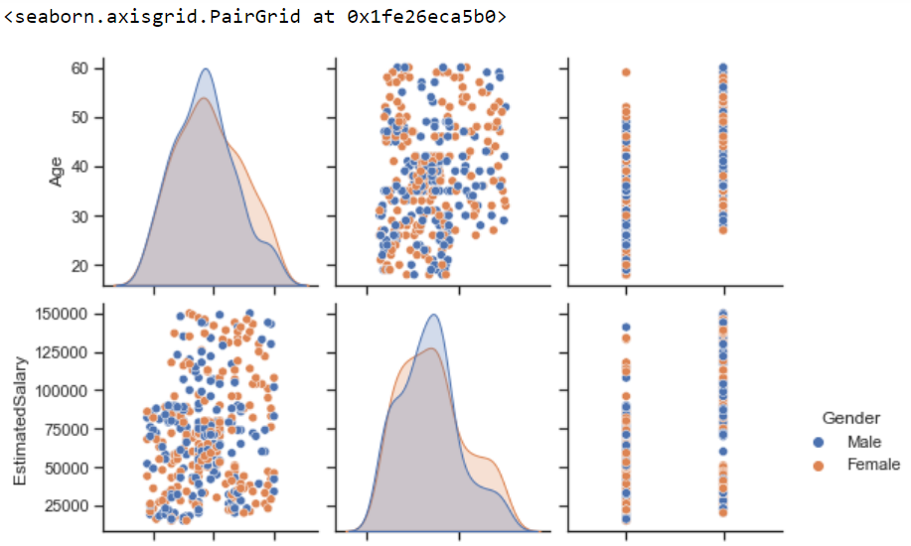

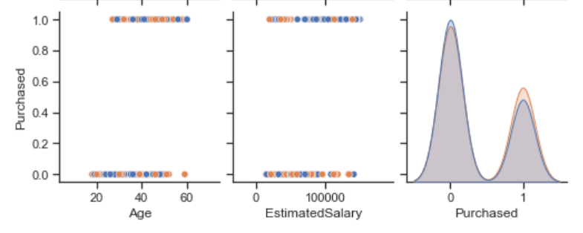

sns.countplot(x="Purchased",data=data)

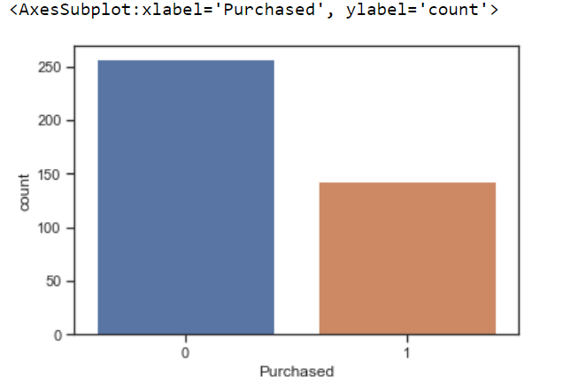

sns.countplot(x="Purchased",hue="Gender",data=data)

